# Exp3 Arrays

**1 Experiment purpose**

Through this training, to understand why arrays are necessary in programming. Grasp how to declare, create, initialize and operate arrays. Grasp how to use multidimensional arrays.

**2 Development Environment**

1. Notepad++
2. JDK 8+

**3 Content and Steps**

**Problem 1:** Design a Sudoku game

The objective is to fill a 9×9 grid with digits so that each column, each row, and each of the nine 3×3 sub-grids that compose the grid contains all of the digits from 1 to 9.

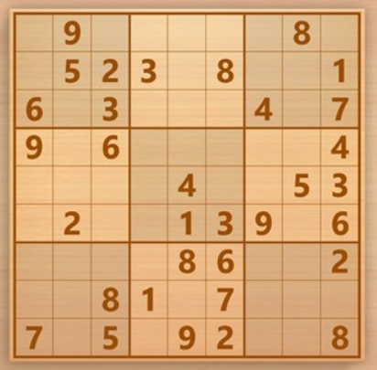

**Steps:**

(1) Design the main business processes.

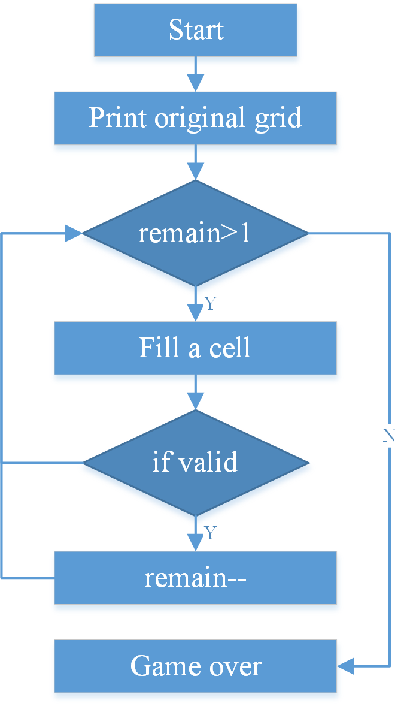

(2) Define a grid using two-dimensional array.

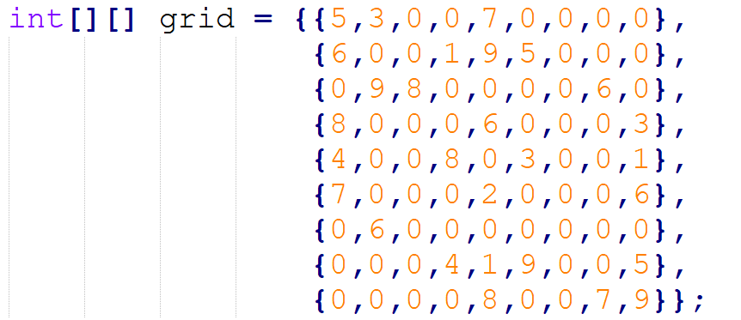 

(3) Print the original state of grid:.

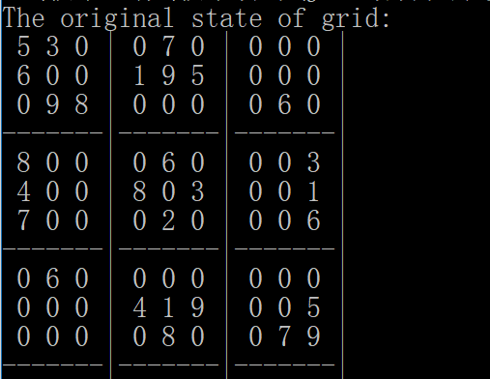

(4) Analyze the number of cells need to fill

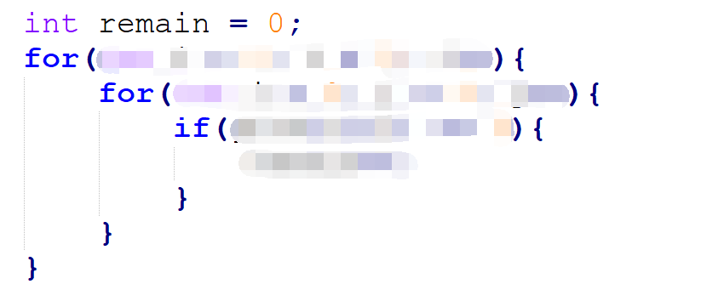

(5) Play the game until the end of the game

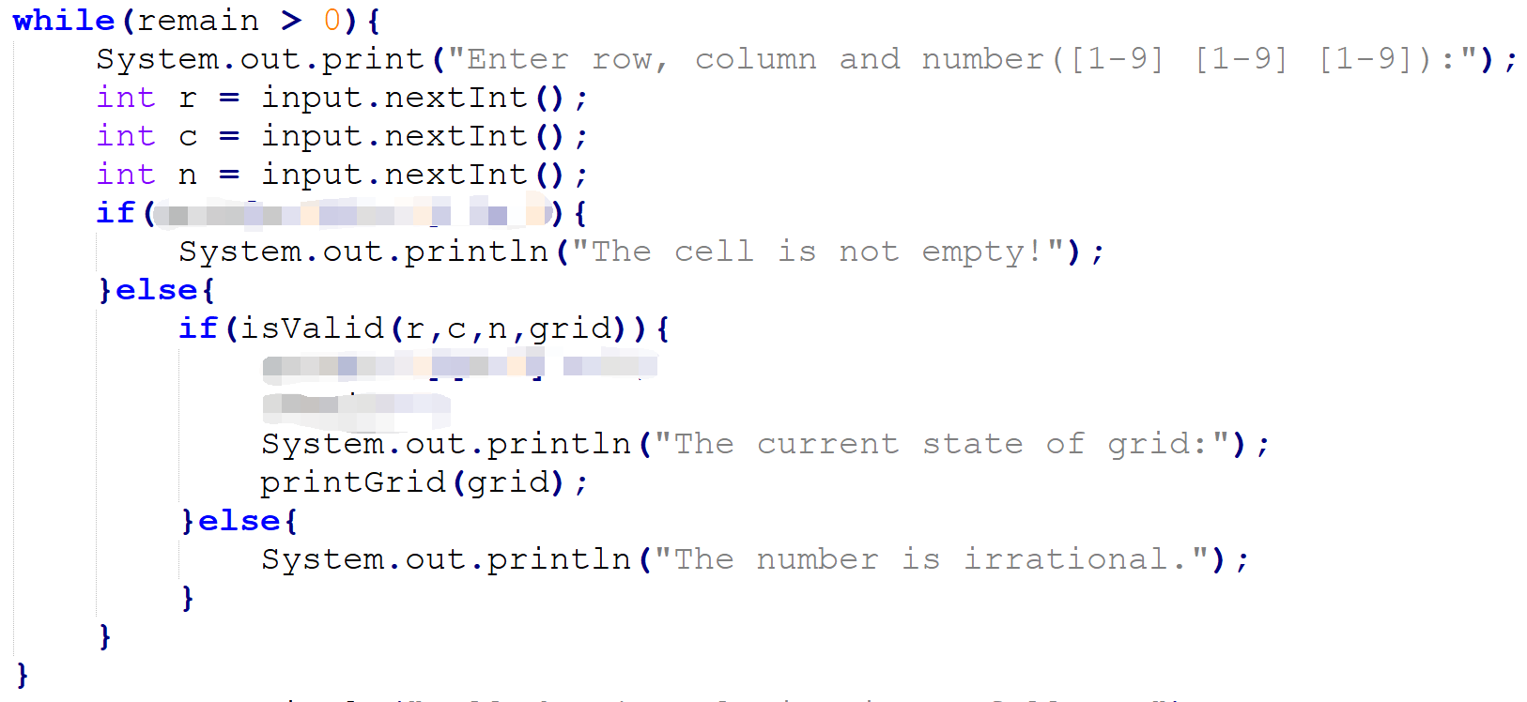

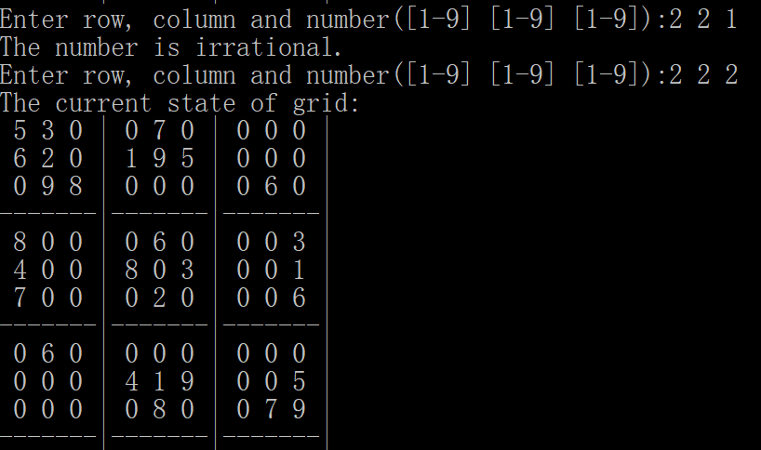

(6) Implement the printGrid() method

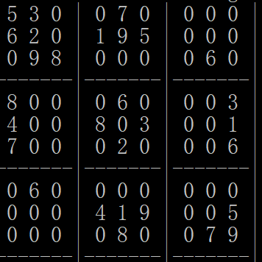

(7) Implement the isValid() method

